Matthew Silva

Professor Lutz Hamel

CSC 301

14 September 2017

Assignment #1

2.1 b. <A>\* ::= <Upper><B>

<B> ::= <Empty> | <Upper><B> | <Digit><B>

<UPPER> ::= A | B | C | … | X | Y | Z

<Digit> ::= 1 | 2 | 3 | 4 | 5 | 6 | 7 | 8 | 9 | 0

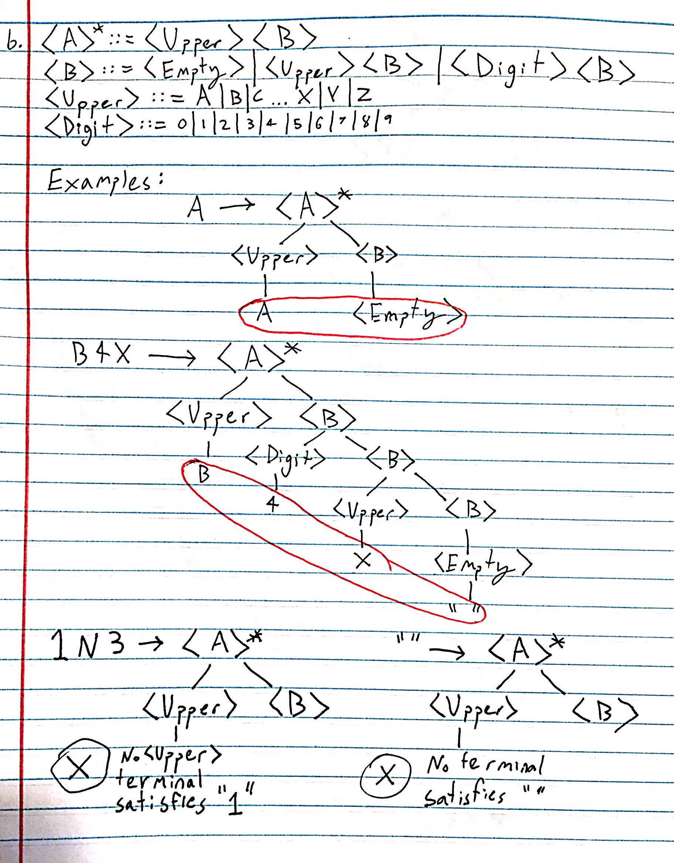

2.1 c. <S>\* ::= a | a<S>

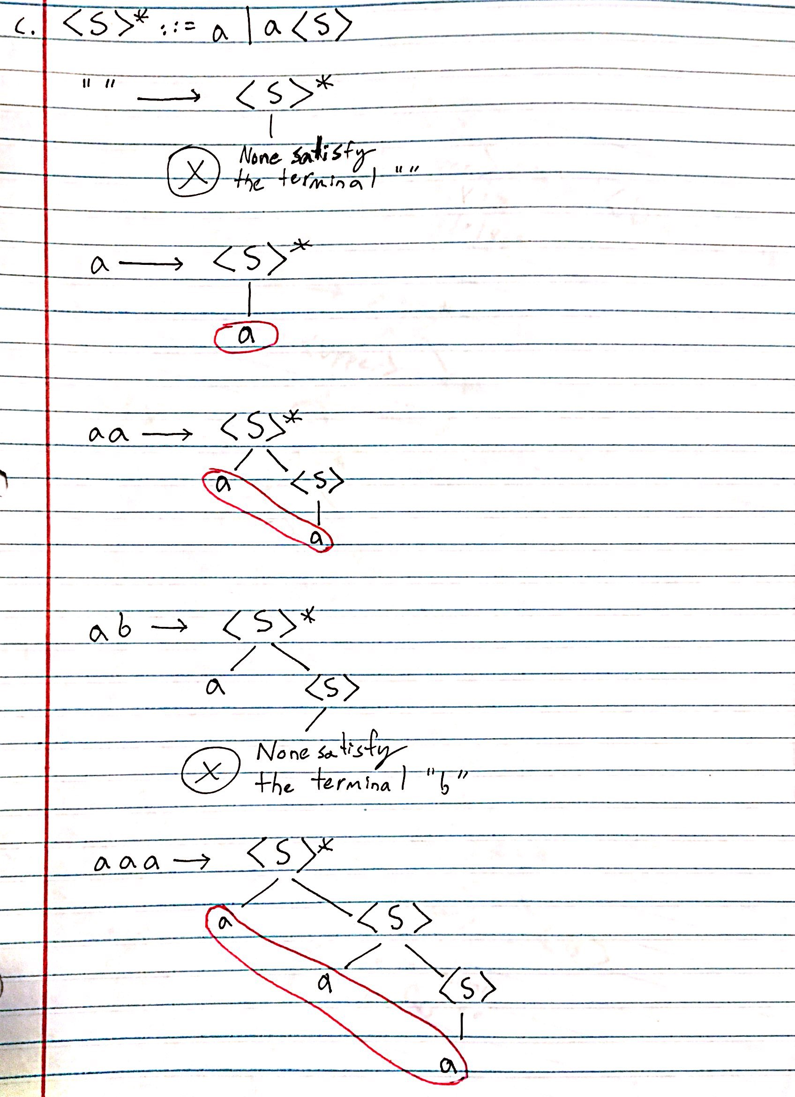

2.1 g. <A>\* ::= a; | a;<A>

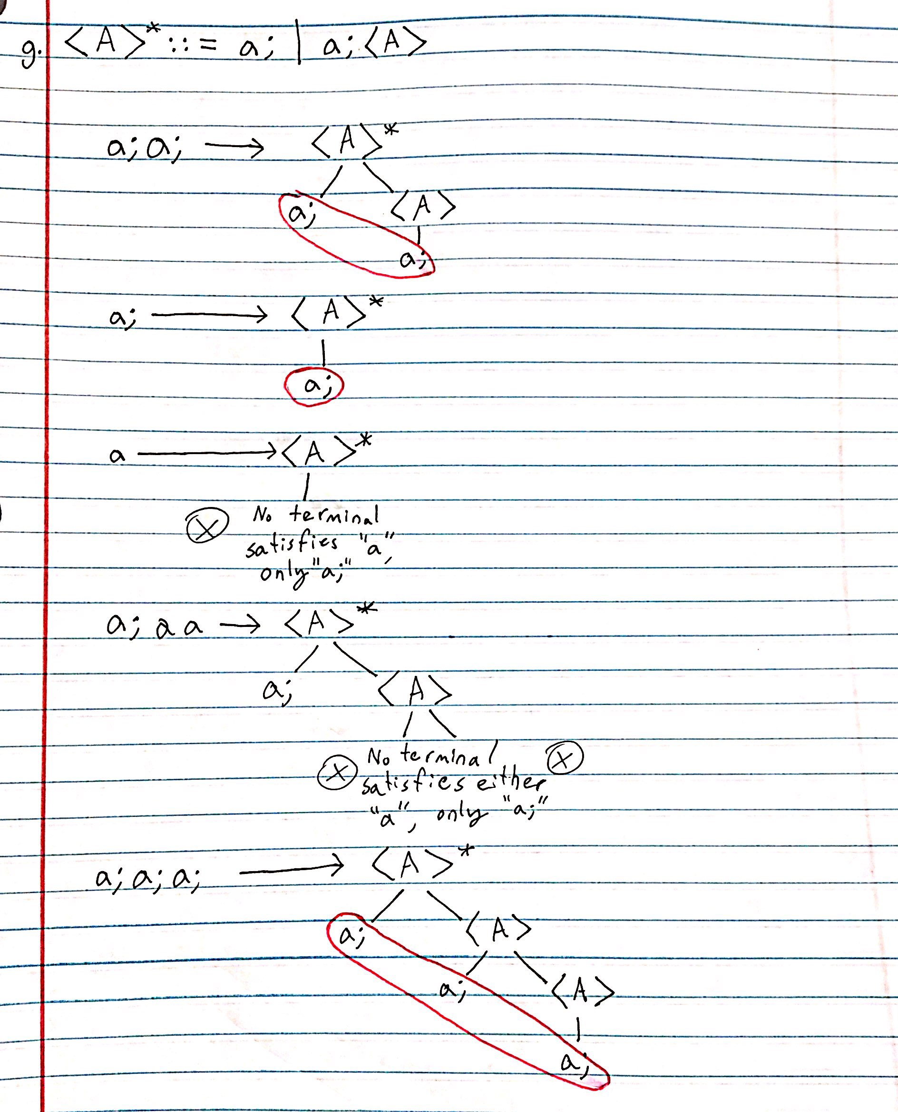

2.1 j. <S>\* ::= [<DigitList>]  
 <DigitList> ::= <Digit> | <Digit>,<DigitList>

<Digit> ::= 0 | 1 | 2 | 3 | 4 | 5 | 6 | 7 | 8 | 9

